Article

Utilizing RT-DETR Model for Fruit Calorie Estimation from Digital Images

GuangLiang Yang *, Wei Qi Yan*

Auckland University of Technology, Auckland 1010 New Zealand

|  |
| --- |
| **Citation:** To be added by editorial staff during production.  Academic Editor: Firstname Lastname  Received: date  Revised: date  Accepted: date  Published: date  A grey and black sign with a person in a circle  Description automatically generated  **Copyright:** © 2023 by the authors. Submitted for possible open access publication under the terms and conditions of the Creative Commons Attribution (CC BY) license (https://creativecommons.org/licenses/by/4.0/). |

**\*** Correspondence: fdp5284@autuni.ac.nz, weiqi.yan@aut.ac.nz

**Abstract:** Estimating the calorie content of fruits is critical for .... In this paper, we investigate the application of deep learning models for estimating … from digital images, aiming to provide a more efficient and accurate method for … analysis. We create a dataset comprising images of … and employ random data augmentation techniques during training to enhance model robustness. We utilize the … model integrated into ultralytics framework for implementation and conduct comparative experiments with YOLO11 on the dataset. Our results show that the … model achieved a precision rate …% and an mAP50-95 of …% in … detection from digital images, outperforming YOLO11 in terms of PR Curves, precision, and mAP. Conclusively, in this paper, we utilize a … architecture to detect … and estimate …. The results of the experiments provide a technical reference for more accurately ….

**Keywords:** Table Tennis, Foul Detection, YOLO, 3D Trajectory Analysis, Multi-Camera System, Machine Learning, Transformer

1. Introduction

In competitive sports, ensuring fair play through consistent rule enforcement is essential for maintaining the integrity of the game. In table tennis, detecting serve fouls accurately is particularly challenging due to the high speed and complex dynamics of the ball and player movements. Serve fouls, such as improper ball toss height, incorrect positioning, or a backward-angled toss, can provide players with unintended advantages. However, human judgment alone may struggle to detect these fouls accurately, especially in high-stakes or fast-paced matches. This has led to the need for automated foul detection systems that can bring precision, consistency, and impartiality to officiating in table tennis.

**Accurate detection of serve fouls** is vital to ensuring fair competition and compliance with table tennis regulations. Traditional manual methods for foul detection are prone to inconsistencies and errors due to the rapid movements involved in serves. An automated system would provide a reliable, objective tool for detecting serve fouls, supporting referees in their decisions and enhancing the fairness of the game.

With advances in computer vision, new tools like YOLO11 (You Only Look Once, version 11) have shown significant improvements in real-time object detection. YOLO11, optimized for detecting small, fast-moving objects, offers the potential for precise and rapid ball tracking, making it particularly suitable for applications in sports. Additionally, multi-camera setups enable 3D reconstruction, capturing the full spatial dynamics of a table tennis serve from multiple perspectives. Despite these advancements, debates remain on optimal detection approaches, including whether single-camera or multi-camera systems provide the best accuracy and how well deep learning models can be adapted to the unique requirements of sports applications.

**This study aims to create an automated table tennis serve foul detection system using 3D ball tracking**, leveraging a multi-camera setup and deep learning techniques like YOLO11 for ball detection and Transformers for sequence analysis. By integrating YOLO11 with a multi-camera system, the proposed solution seeks to achieve high precision in detecting serve fouls by capturing the ball’s trajectory and player movements in 3D space.

**Key contributions** of this study include the development of a multi-camera-based 3D tracking system for table tennis and the application of YOLO11 for small object detection in fast motion. Additionally, the study explores using Transformer models to identify key points in the serve trajectory, enhancing the system’s ability to detect fouls based on movement patterns and ball positioning.

To guide our research, we introduce the following hypotheses:

* **Hypothesis 1**: can be further optimized to improve small object detection accuracy in high-speed ball tracking of table tennis.
* **Hypothesis 2**: Table tennis ball movement can be effectively used for video segmentation to isolate serve sequences.
* **Hypothesis 3**: Deep Learning can accurately identify key turning points (throw, highest, and hit points) in the 3D trajectory of a table tennis serve.

2. Materials and Methods

In this section, we describe the methods we used to achieve relevant results. We will provide a literature review of relevant background studies, followed by a description of the methods used in this project.

2.1 Experimental Setup

To accurately detect serve fouls in table tennis, we utilized a multi-camera setup with high-speed recording capabilities. This configuration was designed to capture the full serve motion from multiple perspectives, providing a comprehensive view necessary for 3D reconstruction and foul detection.

* Multi-Camera Configuration and Equipment: The setup consisted of three high-speed cameras, each connected via USB 3.0 to ensure minimal latency and capable of recording at 60 frames per second (fps). The cameras were strategically positioned around the table tennis table:
  + Primary Cameras (Camera 1 and Camera 2): These cameras were placed to the left and right of the table (as shown in Figure 1) to capture the ball’s trajectory from multiple angles. The two main cameras focused on the critical serve area, allowing for a clear view of the ball’s movement throughout the serve sequence. Their positioning enabled the calculation of 3D coordinates using triangulation, essential for accurate trajectory analysis and foul detection.
  + Verification Camera (Camera 3): The third camera was mounted on the ceiling above the athlete’s head, as seen in Figure 1. This overhead position provided a top-down view that helped cross-verify the ball’s position detected by the primary cameras. The ceiling-mounted camera was not directly involved in 3D reconstruction but was used to improve tracking reliability by offering an additional perspective, particularly useful in cases where the ball might be occluded in the side views.

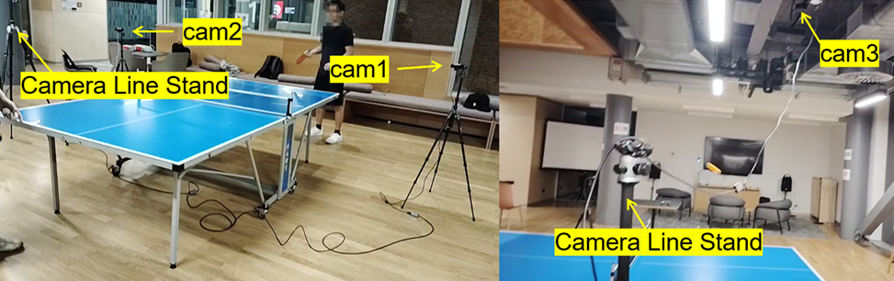  
Figure 1. Multi-camera setup for table tennis serve foul detection. The cameras are positioned to capture different perspectives: two cameras are placed at the left and right sides of the table, while a third camera is mounted overhead.

* Rationale for Multi-Camera Setup: A multi-camera setup was chosen over a single-camera configuration to overcome limitations related to depth perception and occlusions. In high-speed sports like table tennis, tracking the ball’s trajectory and detecting fouls requires a precise 3D perspective, which can only be achieved through synchronized multi-camera views. The combination of these cameras allowed for robust tracking across various angles, minimizing tracking loss and ensuring that the ball’s position could be accurately monitored even in complex scenarios.
* Environmental Control and Setup Conditions: The experiment was conducted in a controlled indoor environment to minimize external interference, such as lighting variations and background noise, which could affect detection accuracy. Uniform lighting was used to reduce shadows and enhance object detection, particularly for small and fast-moving objects like the table tennis ball. The table tennis table was placed at the center of the setup, with clear space around it to allow unobstructed views from all camera angles. Calibration markers were placed on the table to aid in the camera calibration process and improve spatial alignment between the views.
* Software and Hardware Synchronization: To manage video recording and synchronization, OBS (Open Broadcaster Software) was used to record composite video feeds from all three cameras in a single video file, with each camera feed displayed in a separate sub-area of the frame. This approach ensured that all camera views were perfectly synchronized in time, simplifying the process of splitting the video into individual feeds for each camera while maintaining frame alignment. The synchronized video data was essential for accurate 3D reconstruction, as any temporal misalignment could lead to errors in tracking and trajectory analysis.
* Processing Platform: The processing and analysis were performed on a Windows 11 system with a dedicated GPU (Graphics Processing Unit) to accelerate computation-intensive tasks, such as real-time object detection and 3D reconstruction. Python and PyTorch served as the primary programming environment, while YOLO11 and other libraries facilitated object detection and tracking. This setup enabled high-speed processing required to analyze the rapid motion of the ball and detect serve fouls in real time.

2.2 Data Collection and Synchronization

To accurately capture and synchronize the fast-paced movements involved in a table tennis serve, a careful setup for video recording and frame alignment was implemented. This process involved recording synchronized video feeds from multiple cameras and aligning frames across these feeds to enable precise 3D reconstruction of the ball’s trajectory.

OBS was employed to manage the multi-camera setup and ensure frame synchronization across all video feeds. By recording one composite video that includes views from all three cameras in designated sub-areas, OBS allowed for temporal alignment across all views (Figure 2). This composite video was later split into individual feeds for each camera, preserving synchronization.

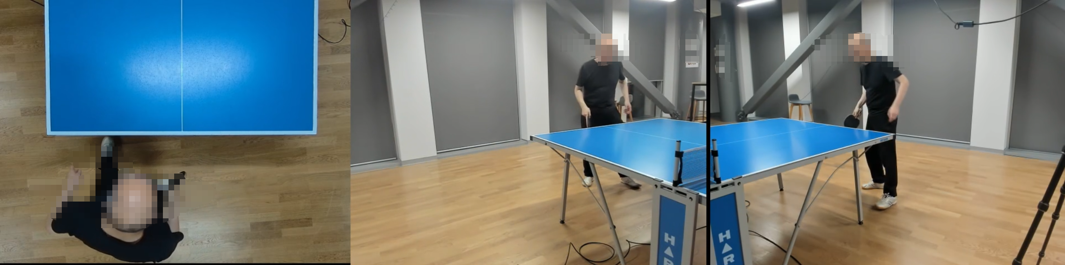

Figure 2. Frame alignment video recorded by OBS. The video layout shows the overhead view from the ceiling-mounted camera (left) and side views from the left and right cameras (right), allowing synchronized data capture across all views.

After recording, the composite video was split into individual video feeds for each camera while preserving the frame-by-frame synchronization established by OBS. This splitting process ensured that every frame from each camera was perfectly aligned in time, To confirm frame alignment, a visual inspection was performed across the individual video feeds. Key points in the serve sequence, such as the ball toss and hit moments, were compared across all views to ensure that these actions occurred simultaneously in each camera’s footage. This alignment is critical for accurate 3D trajectory reconstruction, Without precise alignment, any temporal mismatch between frames could lead to inaccuracies in calculating the ball’s 3D coordinates.

2.3 Calibration and 3D Reconstruction

Calibration involves two main components: intrinsic calibration to determine each camera’s internal parameters and extrinsic calibration to align the cameras with a common coordinate system.

Intrinsic calibration was performed using a chessboard pattern, which is a standard technique in computer vision for determining camera-specific parameters. The chessboard was placed within the view of each camera, and 100 images were captured. These images were then used to calculate each camera’s intrinsic parameters, including focal length, optical center, and lens distortion coefficients[3].

After obtaining intrinsic parameters, extrinsic calibration was conducted to establish a common 3D coordinate system across all cameras. This step involved identifying 16 fixed reference points around the table, as shown in Figure 3, and measuring their precise coordinates. These points were chosen based on their visibility across multiple camera views, ensuring they could serve as reliable references for spatial alignment. Each reference point's position was marked in the video, and its coordinates in the 3D space were recorded. By associating the 2D coordinates of these points in each camera view with their real-world 3D coordinates, the extrinsic parameters for each camera (rotation and translation vectors)[4] were calculated.

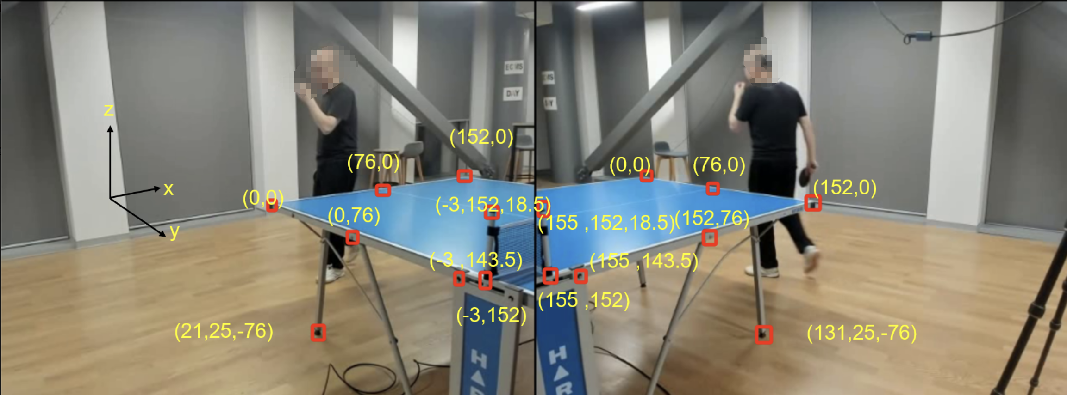Figure 3. Extrinsic calibration points used for aligning cameras to a common coordinate system. The 16 fixed reference points are labeled with their 3D coordinates in the image, providing the foundation for accurate spatial calibration.

2.4 Ball Detection and Tracking

YOLOv11 was selected for its high efficiency in detecting small, fast-moving objects, making it suitable for identifying a table tennis ball in each frame. To optimize YOLOv11 for the specific challenges of this project, several modifications were implemented to improve its accuracy in detecting small objects like the table tennis ball, which is often difficult to track due to its rapid motion and small size in the frame.

The standard YOLOv11 architecture was adapted to enhance its sensitivity to small objects by removing the large object detection layers and incorporating a Resample Convolution (ResConv) layer, as shown in Figure 4. The ResConv layer is designed to better handle small-scale features, allowing the model to focus on the fine details required for detecting small objects like the ball. Additionally, upsampling layers were modified to emphasize finer spatial resolution, which is crucial for capturing the ball's movement accurately, even at high speeds.

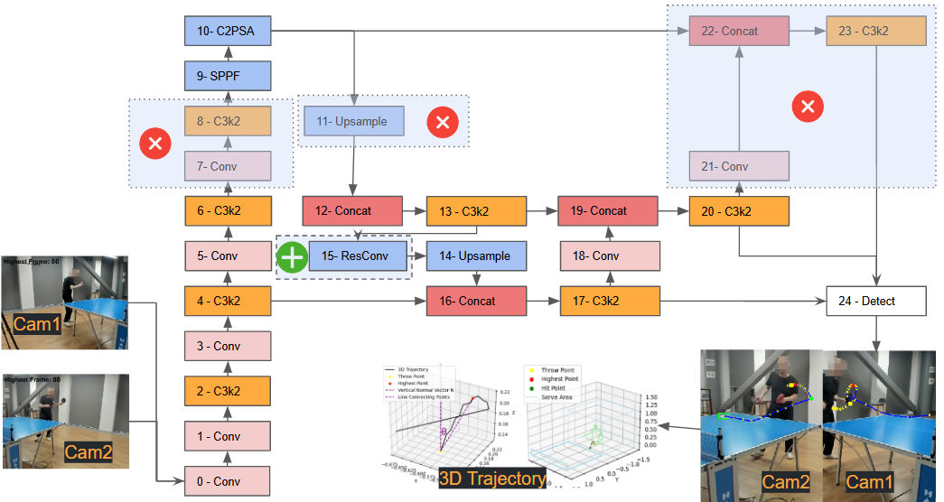

Figure 4. Modified YOLOv11 architecture for small object detection. The large object detection layer is removed, and a ResConv layer is added to enhance detection performance for small, fast-moving objects like the table tennis ball.

The ResConv layer is designed to enhance small object detection by preserving spatial details often lost during traditional downsampling. It divides the input tensor into smaller spatial components, retains localized features, and enriches the feature representation by concatenating these components along the channel dimension. A convolution operation then processes this enriched data to capture critical spatial relationships, improving the model’s ability to detect small objects.

Y=Conv(concat(X[...,::2,::2],X[...,1::2,::2],X[...,::2,1::2],X[...,1::2,1::2]))

Here, X is the input tensor with shape (B,C,H,W), where B is the batch size, C the number of channels, and H,W the spatial dimensions. The input is sliced into four regions, capturing localized spatial information. These slices are concatenated along the channel dimension, resulting in a tensor X′of shape (B,4C,H/2,W/2), with quadrupled channels and halved spatial resolution.

The concatenated tensor X′ is passed through a 3×3 convolution, producing the output Y with shape (B,ouc,H/2,W/2), where ouc is the number of output channels. This process preserves critical details, ensuring robust small object detection while maintaining computational efficiency.

With this optimized YOLOv11 model, the ball was detected simultaneously in frames from two different cameras (Cam1 and Cam2) positioned to capture the serve area from distinct angles. By detecting the ball from two synchronized perspectives, the system can leverage data from multiple views, ensuring consistent tracking and reducing the likelihood of detection loss, even during rapid ball movements.

After detecting the ball in both camera feeds, the system applied calibration theory to reconstruct the ball’s position in 3D space. Using the intrinsic and extrinsic calibration parameters obtained earlier, the 2D coordinates of the ball from each camera were mapped to a common 3D coordinate system. This triangulation process allowed for the precise calculation of the ball's position in 3D, enabling detailed trajectory analysis and accurate detection of key serve points, such as the throw, highest, and hit points.

* Tracking Algorithms

BYTETrack was employed to maintain the table tennis ball’s position across consecutive frames. BYTETrack is designed to associate every detection box, including low-confidence ones, improving its ability to handle objects with varying detection scores. Originally introduced in the paper "BYTETrack: Multi-Object Tracking by Associating Every Detection Box" by Yifu Zhang et al. at ECCV 2022, this method has gained prominence for its robustness in tracking objects in challenging scenarios.

BYTETrack operates by categorizing detected boxes from a detector (such as YOLO) into two groups based on their detection confidence: high-confidence detections and low-confidence detections. High-confidence boxes are initially matched to existing tracks using IoU (Intersection over Union) criteria. Subsequently, unmatched low-confidence detections are considered for a second round of association. This two-stage association ensures that objects with inconsistent or weak detections are not prematurely discarded, making BYTETrack particularly effective for tracking small, fast-moving objects like table tennis balls.

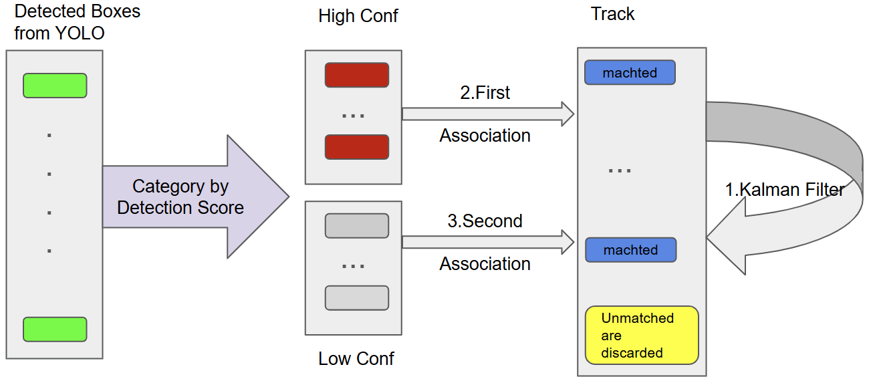

As illustrated in Figure X:

BYTETrack uses a Kalman filter to predict the positions of existing tracks, ensuring that tracks remain consistent and smooth across frames. High-confidence detection boxes are matched to existing tracks based on IoU criteria. This ensures that the most reliable detections are prioritized. After matching high-confidence boxes, low-confidence detections are evaluated. This step addresses missed detections caused by occlusions, motion blur, or other challenging conditions. Unmatched tracks are marked for termination if they persist without updates, while unmatched detections that fail the second association are discarded.

While OpenCV’s background subtraction is a straightforward method for detecting moving objects by isolating changes between frames, it is sensitive to background noise and lighting variations. This can lead to fragmented trajectories, particularly for small and fast-moving objects like table tennis balls

2.5 Video Segmentation

the precise 3D trajectory of the table tennis ball, including its spatial coordinates and temporal sequence, is used as the primary cue for segmenting video. The trajectory spans the entire serve action, from the ball's appearance to its departure from the table. This approach significantly simplifies video segmentation in the context of table tennis serves, eliminating the need for multi-stream models commonly employed in action segmentation studies.

Unlike recent methods that heavily rely on player pose estimation and multi-stream architectures integrating RGB data, optical flow, and player positioning (as seen in table tennis and tennis research), this study focuses exclusively on the ball’s 3D trajectory. The calibrated 3D coordinates of the ball provide sufficient information to isolate serve sequences without relying on additional data streams or complex model architectures.

The segmentation process is straightforward and relies on the ball’s spatial movement within the calibrated 3D space. A threshold of Y>0.5, representing a spatial boundary in the serve area, is used to identify the serve sequence. This criterion isolates the serve action by focusing on the ball’s trajectory during its active involvement in the serve, effectively capturing the temporal and spatial characteristics of the sequence.

.

Start { Three-Stream 3D/1D CNN for Fine-Grained Action Classification and Segmentation in Table Tennis: This study introduces a fusion method utilizing a three-stream network with spatio-temporal and temporal convolutions to achieve fine-grained action classification in table tennis. The approach integrates raw RGB data, computed optical flow, and estimated player pose to detect and classify strokes within untrimmed game videos. The model demonstrates improved performance in both classification and joint segmentation tasks, offering valuable feedback for athletes aiming to enhance their performance.

TTNet: Real-Time Temporal and Spatial Video Analysis of Table Tennis. Another significant contribution is TTNet, a neural network designed for real-time processing of high-resolution table tennis videos. TTNet provides both temporal (event spotting) and spatial (ball detection and semantic segmentation) data, facilitating automated referee systems. The model achieved 97.0% accuracy in game event spotting and 97.5% accuracy in ball detection on the OpenTTGames dataset, which includes 120 fps videos labeled with events, segmentation masks, and ball coordinates.

P2ANet: A Large-Scale Benchmark for Dense Action Detection from Table Tennis Match Broadcasting Videos: Focusing on table tennis, this research presents the Ping Pang Action (P2ANet) benchmark designed for action recognition and localization. The benchmark facilitates research on fine-grained action understanding by providing a comprehensive dataset that captures the intricacies of table tennis matches.

ViSTec: Video Modeling for Sports Technique Recognition and Tactical Analysis: Addressing the strategic nature of racket sports, including tennis and table tennis, ViSTec proposes a video-based model inspired by human cognition. The model synergizes sparse visual data with contextual insights, integrating a graph to explicitly model strategic knowledge in stroke sequences. This approach enhances technique recognition and offers valuable tactical analysis, outperforming existing models in recognizing technical actions and strategies.

} end

2.6 Transformer Model for Key Point Detection

Transformer for Turning Points in Trajectory: In this study, a Transformer model was applied to analyze the 3D trajectory of a table tennis serve and identify key turning points, such as the throw, highest, and hit points. This approach leverages the Transformer’s attention mechanism, which excels in capturing dependencies in sequential data, making it highly effective for recognizing patterns in the ball’s movement over time. By learning from labeled trajectories, the model can accurately predict critical points within the serve sequence, thereby enhancing the system’s ability to detect fouls based on serve dynamics.

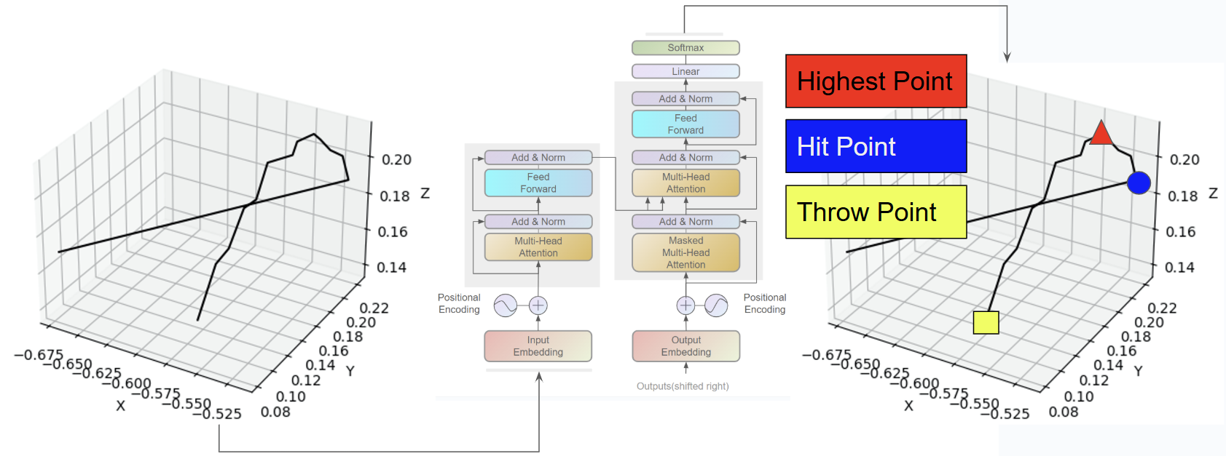

Figure 7. Illustration of the Transformer's role in identifying turning points in the ball's 3D trajectory. The left panel shows the trajectory path with spatial axes (X, Y, Z), while the right panel highlights the annotated turning points (throw point, highest point, and hit point). The schematic of the Transformer model outlines its components, such as multi-head attention, which enables it to process the trajectory data and extract key turning points.

As shown in Figure 7, the Transformer architecture is visualized alongside the 3D trajectory. The trajectory highlights the critical turning points: the throw point (marked as a yellow square), the highest point (marked as a red triangle), and the hit point (marked as a blue circle). The left panel depicts the 3D path of the ball, while the right panel overlays the annotated turning points on the trajectory. The Transformer framework on the right demonstrates how the positional encoding and multi-head attention layers enable the model to process sequential data and extract these key moments with precision.

Studies like S2TNet and the Trajectory Unified Transformer apply Transformer-based models to predict future positions in human motion or traffic data by identifying significant turning points. While these applications involve complex social interactions or environmental factors, the focus here is on the ball’s motion alone, allowing the Transformer to concentrate on the trajectory patterns specific to the serve.

The Transformer model in this study was trained on a dataset of labeled trajectories, where each serve sequence was annotated with the critical points of interest: the throw point (where the ball begins its upward toss), the highest point (the peak of the ball's toss), and the hit point (where the player makes contact). These labels enabled the model to learn the specific patterns associated with each turning point in the serve. The attention mechanism of the Transformer allowed it to discern subtle changes in the ball’s movement over time, capturing dependencies that traditional models might overlook. This ability to track complex temporal dependencies made the Transformer model particularly well-suited for accurately identifying turning points in the trajectory.

References { "On Transforming Reinforcement Learning by Transformer: The Development Trajectory" (2022): This paper examines the integration of Transformer architectures into reinforcement learning, focusing on trajectory optimization. It discusses how Transformers can model sequential decision-making processes, effectively identifying key turning points within trajectories to enhance learning efficiency.

"S2TNet: Spatio-Temporal Transformer Networks for Trajectory Prediction" (2022): This study introduces S2TNet, a Transformer-based network designed to capture spatial and temporal dependencies in trajectory data. The model excels at predicting future positions by identifying significant turning points, demonstrating its utility in applications like traffic forecasting and human motion analysis.

"Trajectory Unified Transformer for Pedestrian Trajectory Prediction" (2023): This research presents a Transformer model that unifies various components of trajectory prediction, including social interactions and multimodal data. The model effectively identifies turning points in pedestrian movements, improving the accuracy of trajectory forecasts in crowded environments. }

2.7 Rule-Based Foul Detection Metrics

The system employs a set of rule-based criteria to determine whether a serve violates table tennis regulations. These criteria are designed to assess various aspects of the serve and provide objective data to assist referees in evaluating serve compliance.

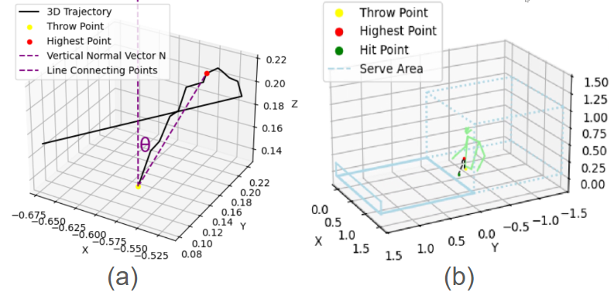

1. Minimum Drop Height: To ensure that the serve meets the minimum height requirement, the system monitors the ball’s trajectory to confirm it reaches a specified drop height. This criterion helps verify that the serve complies with the rules regarding the initial toss height.
2. Vertical Angle at Throw: The system analyzes the initial angle of the ball toss to determine whether it deviates excessively from the vertical axis, as a back-tilt angle of more than 30° may constitute a foul. This angle is calculated using the vector between the throw point and the highest point of the ball’s trajectory, relative to the vertical axis.

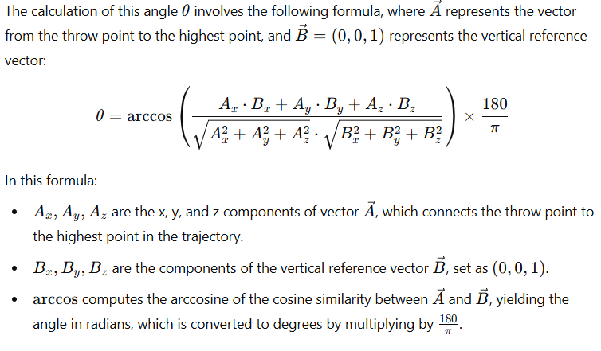

This angle θ provides an objective measurement of the ball’s verticality during the toss. A toss angle exceeding 30° is flagged as a potential foul, indicating that the serve may not comply with the rules due to excessive backward tilt. By applying this precise angle calculation, the system enhances foul detection accuracy, ensuring that each serve meets the sport’s regulations.

1. Service Area Positioning: The 3D coordinates of the ball are continuously tracked to ensure that the ball remains within the designated service area throughout the serve. This positioning check prevents serves from originating outside the permitted boundaries, ensuring compliance with the spatial rules of the game.

These rule-based criteria allow for accurate foul detection by providing objective measures for serve evaluation, supporting referees with precise data on serve compliance.

Multi-Camera Cross-Validation: In addition to the main criteria, the system uses a third camera for cross-validation of tracking accuracy. By comparing the ball’s position across three views, the system confirms that the 3D coordinates are consistent with the physical position of the ball on the table. This cross-validation enhances the reliability of the tracking data and ensures the integrity of foul detection.

Reference{

* "The Development of Table Tennis Service Rules and Their Impact on the Game": This study examines the historical changes in service regulations and how they have affected gameplay strategies and player performance.
* "Analysis of the Effectiveness of Various Table Tennis Serves Under Current ITTF Regulations": This research evaluates the success rates of different serving techniques within the framework of existing International Table Tennis Federation (ITTF) rules.
* }

3. Results

In this section, we provide a detailed analysis of the results produced by the models we trained. All training results refer to the model being trained on our dataset for 300 epochs, with a batch size of 16.

**3.1 Object Detection**

**Table 1.** Performance values of YOLOv8, YOLO11m and Ours

|  |  |  |  |  |  |  |
| --- | --- | --- | --- | --- | --- | --- |
|  | **Precision** |  | **Recall** | **mAP50** | **mAP50-95** | **Training Time** |
| **YOLOv8** | 84.92% |  | 75.40% | 81.30% | 36.30% | 3hrs24mins |
| **YOLO11m** | 81.25% |  | 81.25% | 84.12% | 38.12% | 4hrs59mins |
| **Ours** | 87.52% |  | 83.37% | 86.87% | 39.84% | 4hrs33mins |

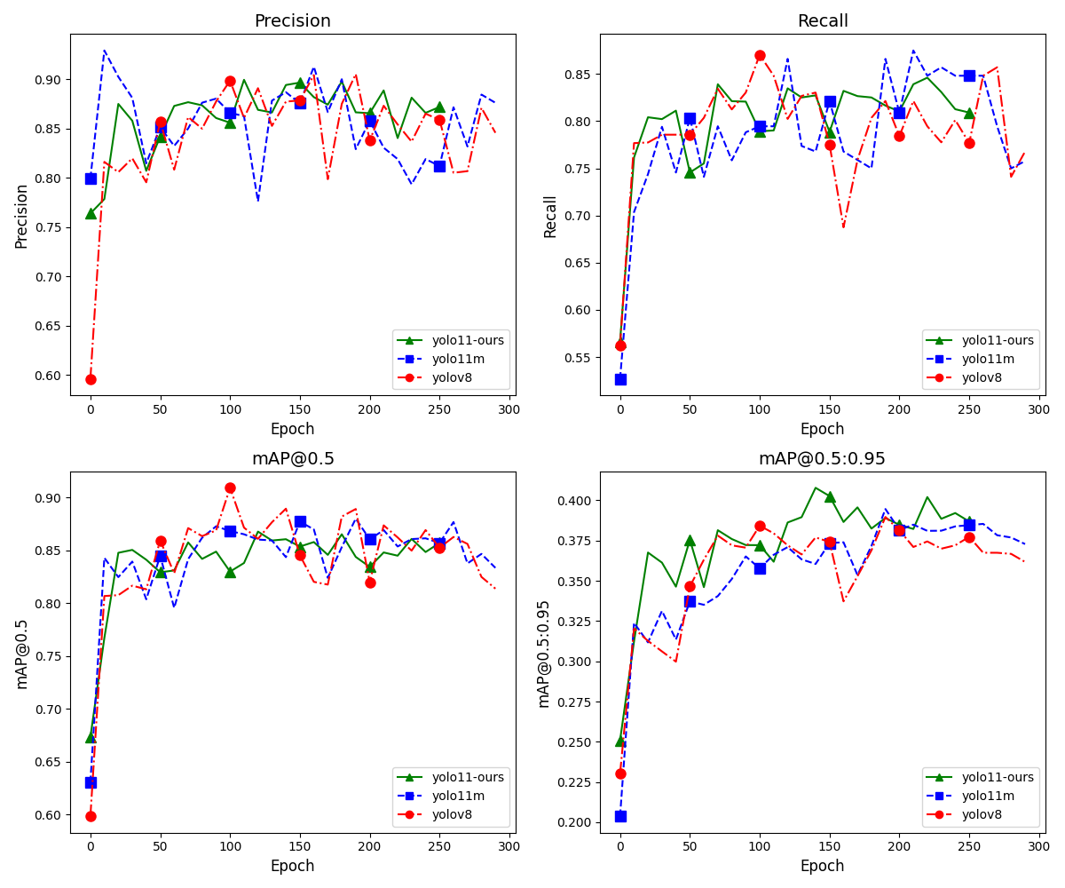

**3.4. Tracking**

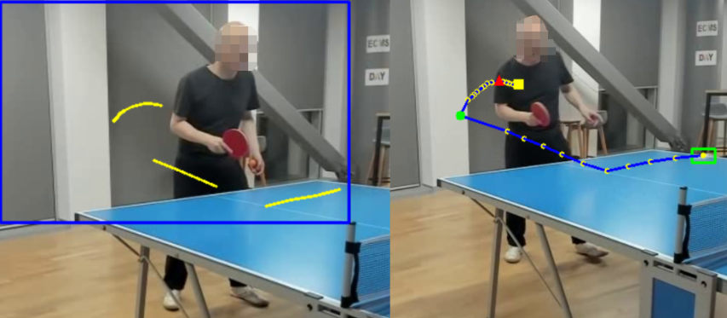

Figure 5. Comparison of tracking methods: OpenCV background subtraction (left) and Byte-Track (right). Byte-Track achieves smoother and more continuous tracking of the ball’s trajectory, while background subtraction results in more fragmented detection.

Background subtraction using OpenCV is a straightforward technique for detecting moving objects in a relatively static scene. This method isolates areas of movement by highlighting changes between frames, making it effective for tracking objects like a table tennis ball against a stable background. In this study, OpenCV’s background subtraction algorithm was applied to detect the ball, as shown in the left side of Figure 5. Although this approach efficiently captures the ball’s movement, it is sensitive to background noise and can struggle with fragmented trajectories, especially when dealing with fast, complex motion. Shadows, reflections, and rapid ball movements often interfere with detection, causing the track to break or become inconsistent.

In contrast, Byte-Track offers a more advanced tracking solution, designed to handle complex motion patterns by associating detected objects across frames based on features like object size, consistency of movement, and positional prediction. The right side of Figure 5 illustrates Byte-Track’s performance, showcasing a smoother, more continuous tracking of the ball’s trajectory. Unlike background subtraction, Byte-Track maintains a stable trajectory even when the ball undergoes rapid directional changes. Its robustness makes it particularly well-suited for the high-speed dynamics of a table tennis serve, where maintaining track continuity is essential for precise trajectory analysis.

**Video Segmentation Results**

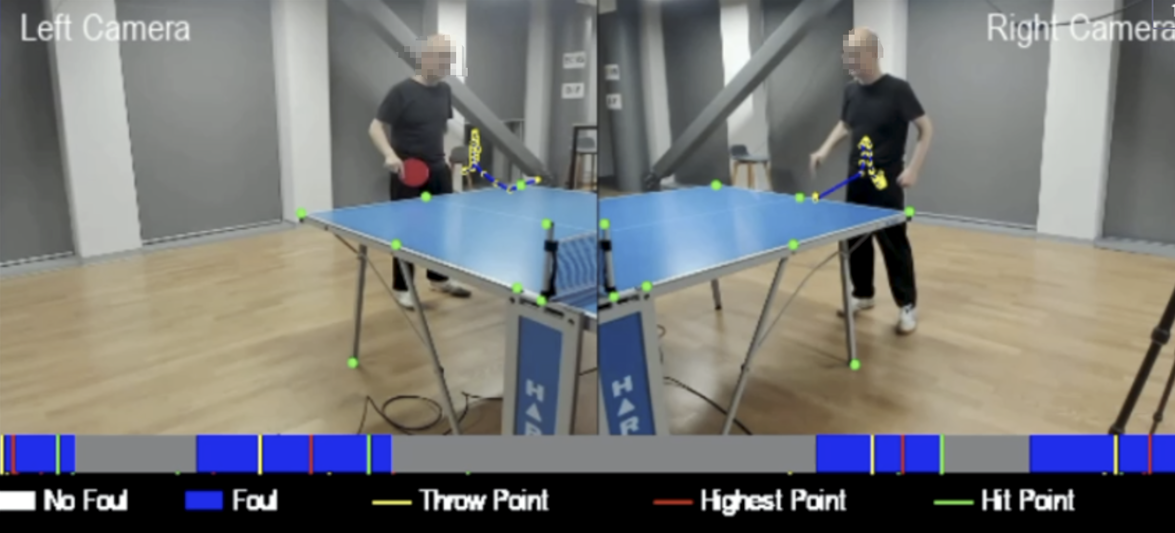

**Figure 6. Experimental results of video segmentation. The top part shows the visualized ball trajectory and key points ("Throw Point," "Highest Point," "Hit Point"), while the bottom timeline indicates the segmented actions, categorized into "No Foul," "Foul," and action-specific segments.**

As shown in **Figure 6**, the segmentation process accurately isolates the serve sequences and identifies key turning points, including the throw point, highest point, and hit point. The visualization further highlights the system's ability to differentiate between fouls and valid serves by categorizing the video into distinct segments: "No Foul," "Foul," and key action points ("Throw Point," "Highest Point," "Hit Point").

The bottom timeline bar in **Figure 6** provides a clear visualization of the segmentation results for each camera, illustrating the corresponding segments for serve actions. The precise alignment between the detected key points and the visualized 3D trajectory validates the robustness of the system in segmenting serve sequences without relying on player pose data. These results confirm the simplicity and accuracy of the proposed approach, leveraging spatial and temporal cues from the ball's motion to achieve reliable and efficient video segmentation for table tennis serve analysis.

**Transformer Find Turning Points**

Recent research, such as "Trajectory Unified Transformer for Pedestrian Trajectory Prediction" and "S2TNet: Spatio-Temporal Transformer Networks for Trajectory Prediction", utilizes Transformer models to capture spatial-temporal dependencies in trajectories across crowded or complex environments. These models are designed to handle interactions between multiple agents, such as pedestrians or vehicles, predicting turning points based on social and environmental cues. In contrast, this study’s approach is streamlined to focus solely on the ball’s trajectory, eliminating the need to account for external influences. This focus on the ball’s motion allows the Transformer to capture precise temporal patterns unique to table tennis serves, leading to a high level of accuracy in predicting serve-specific turning points.

Moreover, unlike models like S2TNet, which often require additional multimodal data (e.g., social interactions or traffic patterns) to improve prediction accuracy, this study relies exclusively on the ball’s 3D trajectory. This simplification reduces computational demands, making the model more efficient and better suited for real-time applications in table tennis serve analysis.

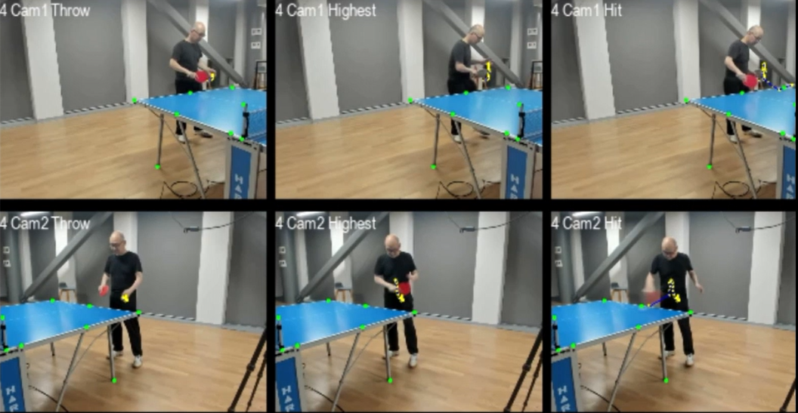

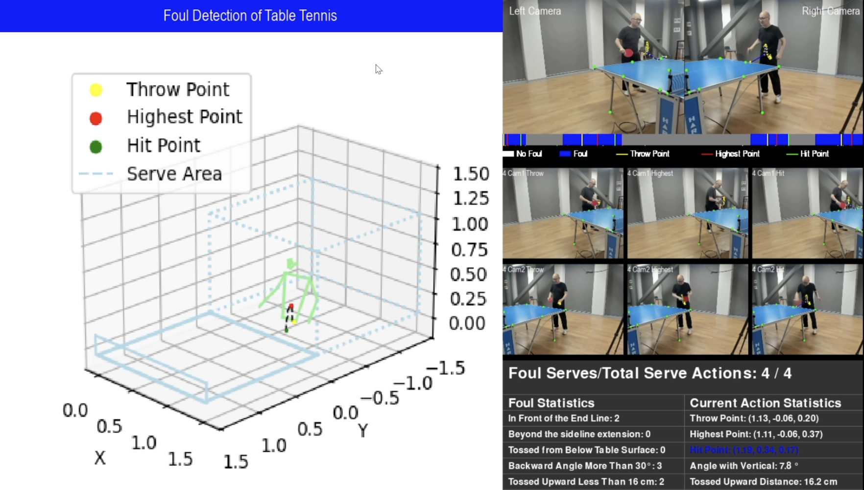

4. Discussion

This project aims to investigate the application of deep learning models for estimating …. To achieve this goal, we generated a dataset from videos captured by ourselves. We trained the … model on our dataset and performed detection in real-time environment. We will discuss the results, explore the limitations of the project, and examine potential future directions based on the training and real-time detection outcomes and the three hypotheses.

4.1 can be further optimized to improve small object detection accuracy in specific scenarios, such as high-speed ball tracking in table tennis?

4.2 Table tennis ball movement can be effectively used for video segmentation to isolate serve sequences?

Recent advancements in video and action segmentation for sports, such as table tennis and tennis, have emphasized player pose estimation as a key feature. Multi-stream models, which combine RGB, optical flow, and pose data, offer detailed insights into player and ball interactions for comprehensive gameplay analysis. However, these methods often come with significant computational costs and require elaborate architectures to model the interplay between player movements and ball trajectories.

In contrast, this study’s segmentation method avoids such complexity by relying solely on the ball’s motion. By forgoing player pose data, the approach minimizes model requirements while maintaining high accuracy in serve-specific segmentation. This focus on the ball’s trajectory leverages the distinct and consistent movement patterns of the ball during a serve, which are sufficient for accurately isolating serve sequences. Furthermore, this simplification eliminates the need for large training datasets, making the method more efficient and suitable for real-time applications in table tennis.

4.3 Transformer models can accurately identify key turning points (throw, highest, and hit points) in the 3D trajectory of a table tennis serve.

4.5 Limitations and future work

5. Conclusion

**Author Contributions:** Conceptualization, S.T. and W.Q.Y.; methodology, S.T.; software, S.T.; validation, S.T.; formal analysis, S.T.; investigation, S.T.; resources, S.T., W.Q.Y.; data collection, S.T.; writing—original draft preparation, S.T.; writing—review and editing, S.T. W.Q.Y.; visualization, S.T.; supervision, W.Q.Y.; project administration W.Q.Y. All authors have read and agreed to the published version of the manuscript.

**Funding:** This research has no external fundings.

**Data Availability Statement:** Data sharing is not applicable.

**Conflicts of Interest:** The authors declare no conflict of interest.

References

1. Mansoor, S.; Jain, P.; Hassan, N.; Farooq, U.; Mirza, M. A.; Pandith, A. A.; Iqbal, Z. Role of Genetic and Dietary Implications in the Pathogenesis of Global Obesity. *Food Reviews International*. 2022 38(S1), pp.434–455
2. Rolls, E. T. Understanding the Mechanisms of Food Intake and Obesity. *Obesity Reviews*. 2007, 8(Suppl. 1), pp.67–72

**Disclaimer/Publisher’s Note:** The statements, opinions and data contained in all publications are solely those of the individual author(s) and contributor(s) and not of MDPI and/or the editor(s). MDPI and/or the editor(s) disclaim responsibility for any injury to people or property resulting from any ideas, methods, instructions or products referred to in the content.